~~Economic Development Conference~~

Shelly Cashman Access 2019 | Modules 4-7: SAM Capstone Project 1a



~~Enhancing Forms and Reports~~

# ~~GETTING STARTED~~

* ~~Open the file~~ **~~SC_AC19_CS4-7a_~~*~~FirstLastName~~*~~_1.accdb~~**~~, available for download from the SAM website.~~
* ~~Save the file as~~ **~~SC_AC19_CS4-7a_~~*~~FirstLastName~~*~~_2.accdb~~** ~~by changing the “1” to a “2”.~~

~~If you do not see the .accdb file extension in the Save As dialog box, do not type it. The program will add the file extension for you automatically.~~

* ~~Open the~~ **~~_GradingInfoTable~~** ~~table and ensure that your first and last name is displayed as the first record in the table. If the table does not contain your name, delete the file and download a new copy from the SAM website.~~
* ~~PROJECT STEPS~~

1. ~~The Economic Development Professional Organization hosts an annual conference for its members, college students, and other interested persons to share new ideas, discuss problems, and brainstorm solutions. You are a conference coordinator responsible for registration.   
     
   Open the~~ *~~Advertisers~~* ~~table in Design View. Use the Input Mask Wizard to add an input mask to the~~ *~~ContactPhone~~* ~~field using the following options:~~
   1. ~~Use the~~ **~~Phone Number~~** ~~input mask with the Input Mask format~~ **~~!(999) 000-0000~~** ~~and the underscore (_) as the placeholder character.~~
   2. ~~The input mask should store the values~~ **~~without symbols~~** ~~in the mask. (~~*~~Hint:~~* ~~Some of these values might be the default input mask values.)~~
   3. ~~Save and close the table.~~
2. ~~Use the Form Wizard to create a new form based on the~~ *~~Exhibitors~~* ~~table using the following options:~~
   1. ~~Select all fields in the~~ *~~Exhibitors~~* ~~table.~~
   2. ~~Use the~~ **~~Columnar~~** ~~layout.~~
   3. ~~Use~~ **~~Exhibitors Information~~** ~~as the title of the form.  
        
      View the~~ *~~Exhibitors Information~~* ~~form in Form View, and then save and close the form.~~
3. ~~Open the~~ *~~Attendee Registration Form~~* ~~in Design View and update the form as follows:~~
   1. ~~Add the~~ *~~CellPhone~~* ~~control and label to the form directly below the~~ *~~LastName~~* ~~control and label.~~
   2. ~~Select the~~ *~~CellPhone~~* ~~and~~ *~~Status~~* ~~controls and their associated labels, and then align them using the~~ **~~Top~~** ~~option.~~
   3. ~~Select the~~ *~~LastName~~* ~~and~~ *~~CellPhone~~* ~~controls and align them using the~~ **~~Left~~** ~~option.~~
   4. ~~Select the~~ *~~LastName~~* ~~and~~ *~~CellPhone~~* ~~labels and align them using the~~ **~~Left~~** ~~option.~~
   5. ~~Change the tab order so that users tab to the~~ *~~CellPhone~~* ~~control directly after the~~ *~~LastName~~* ~~control.  
        
      Save but do not close the form.~~
4. ~~With the~~ *~~Attendee Registration Form~~* ~~still open in Design View, ensure that the~~ **~~Use Control Wizards~~** ~~button is selected. Use the~~ **~~Subform/Subreport Wizard~~** ~~to add a subform with the following options:~~
   1. ~~Use the~~ *~~Registration~~* ~~table for the subform.~~
   2. ~~Select the~~ *~~RegistrationID~~*~~,~~ *~~AttendeeID~~*~~,~~ *~~RegistrationFee~~*~~,~~ *~~WorkshopFee~~*~~, and~~ *~~GuestFee~~* ~~fields (in that order) from the~~ *~~Registration~~* ~~table to add to the subform.~~
   3. ~~Accept the default link (Show Registration for each record in Attendees using AttendeeID) to link the main form to the subform.~~
   4. ~~Save the subform using~~ **~~Registration Details~~** ~~as the subform name.~~
   5. ~~If necessary, reposition the subform to match the approximate location shown in Figure 1. (~~*~~Hint:~~* ~~The left edge of the subform is at .5" mark on the horizontal ruler and the top of the subform label is at the 2" mark on the vertical ruler.)  
        
      Save the~~ *~~Attendee Registration Form~~* ~~but do not close it.~~
5. ~~With the~~ *~~Attendee Registration Form~~* ~~still open in Design View, add a title to the form. Change the title text using~~ **~~Attendee Registration Detail Form~~** ~~as the new title. Save and close the form.~~

* ~~Figure 1: Attendee Registration Form in Design View~~

~~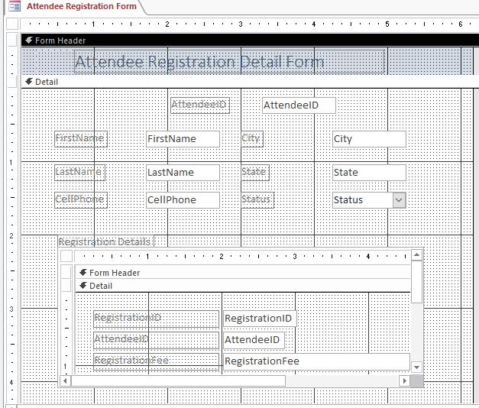~~

1. ~~Open the~~ *~~Advertiser Data Entry Form~~* ~~in Design View and ensure that the~~ **~~Use Control Wizards~~** ~~button is selected. Add a combo box to the right side of the Form Header section as described below:~~
   1. ~~The combo box should find a record in the form.~~
   2. ~~The~~ *~~AdvertiserID~~* ~~and~~ *~~AdvertiserName~~* ~~fields (in that order) should be selected for the combo box.~~
   3. ~~The key column should be hidden.~~
   4. ~~Use~~ **~~Find Advertiser~~** ~~as the label for the combo box.~~
   5. ~~Resize and reposition the combo box control and label to the approximate location shown in Figure 2. (~~*~~Hint:~~* ~~The left edge of the combo box control is at the 4" mark on the horizontal ruler and the bottom edge of the control is at the 1" mark on the vertical ruler.)  
        
      Save the changes to the~~ *~~Advertiser Data Entry Form~~* ~~but do not close it.~~
2. ~~With the~~ *~~Advertiser Data Entry Form~~* ~~still open in Design View, add a command button to the right side of the Form Footer with these options:~~
   1. ~~The command button action should close the form (using the Close Form action.)~~
   2. ~~The button should display the text~~ **~~Close~~** ~~and no picture.~~
   3. ~~Use~~ **~~Close Form~~** ~~as the meaningful name for the command button.~~
   4. ~~The command button should be positioned in the Form Footer section with the left edge at approximately the 4" mark on the horizontal ruler, as shown in Figure 2.  
        
      Save the~~ *~~Advertiser Data Entry Form~~* ~~but do not close it.~~
3. ~~With~~ *~~Advertiser Data Entry Form~~* ~~still open in Design View, add a rectangle control to enclose the~~ *~~ContactFName~~*~~,~~ *~~ContactLName~~*~~, and~~ *~~ContactPhone~~* ~~labels and controls:~~
   1. ~~The upper-left corner of the rectangle should be located at approximately the 1" mark on the vertical ruler and the 3" mark on the horizontal ruler.~~
   2. ~~The lower-right corner of the rectangle should be located at approximately the 2.1" mark on the vertical ruler and the 5.5" mark on the horizontal ruler.   
        
      Save the~~ *~~Advertiser Data Entry Form~~* ~~but do not close it.~~
4. ~~With the~~ *~~Advertiser Data Entry Form~~* ~~still open in Design View, make the following formatting changes:~~
   1. ~~Use the Format Painter to copy the formatting from the~~ *~~AdvertiserID~~* ~~label to the other five labels in the Detail section of the form.~~
   2. ~~In the Detail section of the form, change the fore color of the~~ *~~AdvertiserID~~*~~,~~ *~~AdvertiserName~~*~~,~~ *~~Cost~~*~~, ContactFName,~~ *~~ContactLName~~*~~, and~~ *~~ContactPhone~~* ~~controls to~~ **~~Blue~~** ~~(last row, 8th column in the Standard Color palette).  
        
      Save the~~ *~~Advertiser Data Entry Form~~*~~, compare the form to Figure 2, and close the form.~~

* ~~Figure 2: Advertiser Data Entry Form in Design View~~

~~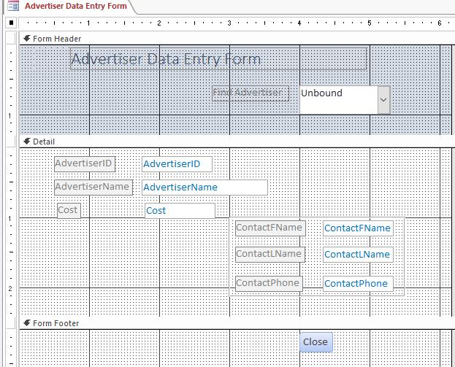~~

1. ~~Use the Report Wizard to create a multi-table report as described below:~~
   1. ~~Add the~~ *~~FirstName~~* ~~and~~ *~~LastName~~* ~~fields (in that order) from the~~ *~~Attendees~~* ~~table.~~
   2. ~~Add the~~ *~~RegistrationFee~~*~~,~~ *~~WorkshopFee,~~* ~~and~~ *~~GuestFee~~* ~~(in that order) from the~~ *~~Registration~~* ~~table to the report.~~
   3. ~~The data should be viewed~~ **~~by Attendees~~** ~~with no additional grouping levels.~~
   4. ~~Sort the report in ascending order by~~ *~~RegistrationFee~~*~~.~~
   5. ~~Use the~~ **~~Stepped~~** ~~layout and the~~ **~~Portrait~~** ~~orientation for the report.~~
   6. ~~Use~~ **~~Registered Attendees~~** ~~as the report title  
        
      Compare your report to Figure 3, and then save and close the report.~~

* ~~Figure 3: Registered Attendees in Report View~~

~~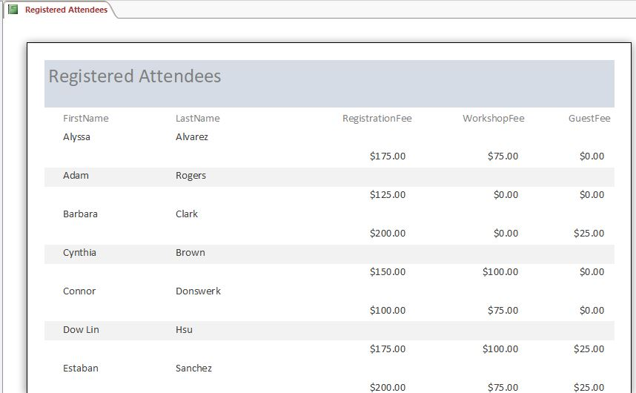~~

1. ~~Use the Label Wizard to create mailing labels for the~~ *~~Attendees~~* ~~table using the following options:~~
   1. ~~Use the~~ **~~Avery C2160~~** ~~label size, which has dimensions of 1 1/2" X 2 1/2" and three columns.~~
   2. ~~Use~~ **~~Arial~~** ~~font,~~ **~~12 point~~** ~~font size,~~ **~~Normal~~** ~~font weight, and~~ **~~Black~~** ~~font color with no special font styles for the labels. (~~*~~Hint:~~* ~~These formatting options may be the default settings for your label.)~~
   3. ~~On the first line of the label, include the~~ *~~FirstName~~* ~~field, a space, and the~~ *~~LastName~~* ~~field.~~
   4. ~~On the second line of the label, include the~~ *~~Address~~* ~~field.~~
   5. ~~On the third line of the label, include the~~ *~~City~~* ~~field, a comma (,), a space, the~~ *~~State~~* ~~field, a space, and then the~~ *~~ZIP~~* ~~field. Your label should match the label in Figure 4.~~
   6. ~~Sort the labels by the~~ *~~LastName~~* ~~field and then the~~ *~~FirstName~~* ~~field.~~
   7. ~~Use~~ **~~Attendee Mailing Labels~~** ~~as the name for the labels report. (~~*~~Hint:~~* ~~If you receive a message indicating all information may not be displayed, click OK.) Preview the mailing labels, confirming they match Figure 5. Save and close the~~ *~~Attendee Mailing Labels~~* ~~report.~~

* ~~Figure 4: Attendee Prototype Level~~

~~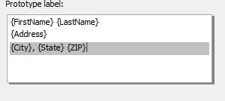~~

* ~~Figure 5: Attendee Mailing Labels in Print Preview View~~

~~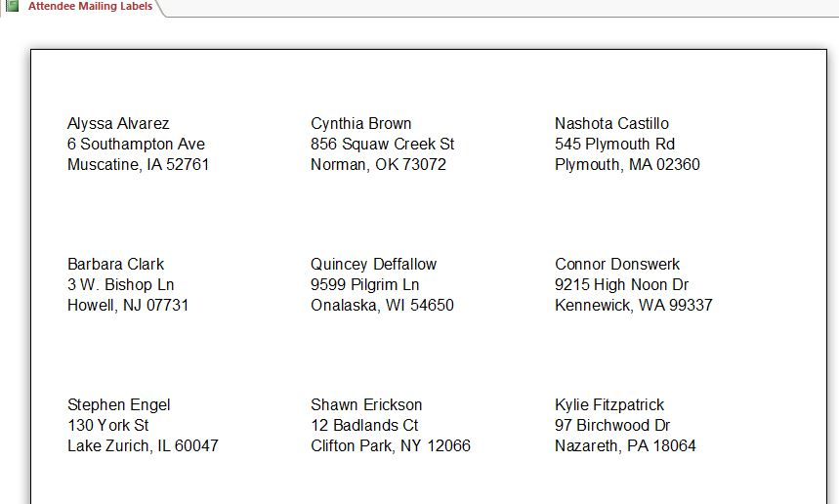~~

1. ~~Open the~~ *~~Registrations by Workshop~~* ~~report in Layout View. Open the Group, Sort, and Total pane, and then add an~~ **~~ascending~~** ~~sort order on the~~ *~~RegistrationID~~* ~~field within the~~ *~~WorkshopID~~* ~~group. Save but do not close the report.~~
2. ~~With the~~ *~~Registrations by Workshop~~* ~~report still open in Layout View, select the~~ *~~WorkshopFee~~* ~~column, and then add~~ **~~subtotals~~** ~~and a~~ **~~grand total~~** ~~to the column using the~~ **~~Sum~~** ~~function. Save but do not close the report.~~
3. ~~With the~~ *~~Registrations by Workshop~~* ~~report still open in Layout View, apply~~ **~~conditional formatting~~** ~~to the values in the~~ *~~ConferenceFees~~* ~~column so that if the field value is~~ **~~greater than or equal to 275~~**~~, the field's font color is set to~~ **~~Green~~** ~~(last row, 6th column of the Standard Colors palette) and the font is~~ **~~bold~~**~~. Compare the report to Figure 6, and then save and close the~~ *~~Registrations by Workshop~~* ~~report.~~

* ~~Figure 6: Registrations by Workshop report in Layout View~~

~~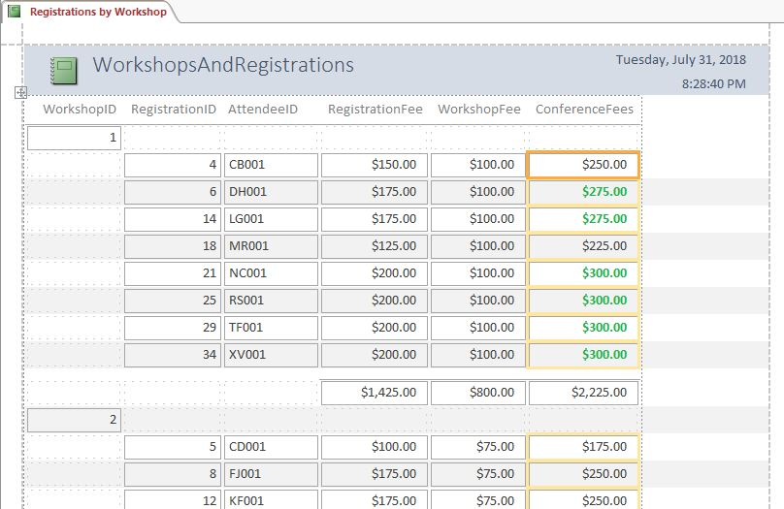~~

1. ~~Open the~~ *~~Advertisers Contact Report~~* ~~in Design View and set the Record Source property to the~~ *~~Advertisers Contact Query~~*~~. Save and close the~~ *~~Advertisers Contact Report.~~*
2. ~~Open the~~ *~~Registrations by State~~* ~~report in Design View, and add a grouping field to the report as described below:~~
   1. ~~Open the Group, Sort, and Total pane, and add the~~ *~~State~~* ~~field as a grouping field.~~
   2. ~~Select the~~ *~~State~~* ~~header and change the Repeat Section property value to~~ **~~Yes~~**~~.~~
   3. ~~With the~~ *~~State~~* ~~header still selected, modify the Force New Page property so that a new page should be created after every section (using the~~ **~~After Section~~** ~~option).  
        
      Save the~~ *~~Registrations by State~~* ~~report, but do not close it.~~
3. ~~With the~~ *~~Registrations by State~~* ~~report still open in Design View, add a field to the~~ *~~State~~* ~~group header as described below:~~
   1. ~~Add the~~ *~~State~~* ~~field to the~~ *~~State~~* ~~header as shown in Figure 7.~~
   2. ~~Delete the label associated with the~~ *~~State~~* ~~control.~~
   3. ~~Select the~~ *~~State~~* ~~control and modify it to display with a font size of~~ **~~14 point~~** ~~and a font weight of~~ **~~Bold~~**~~.~~
   4. ~~Reposition the~~ *~~State~~* ~~control so that the left edge is at the left margin.~~
   5. ~~Resize the State control so that the right edge of the control is at the 1.5" mark on the horizontal ruler.  
        
      Save the~~ *~~Registrations by State~~* ~~report, but do not close it.~~
4. ~~With the~~ *~~Registrations by State~~* ~~report still open in Design View, add page numbers and dates to the report as described below:~~
   1. ~~Add the~~ **~~Date~~** ~~to the report using the~~ **~~Short Date~~** ~~(e.g., 12/12/2019) format. Do not include the time in the report.~~
   2. ~~Add~~ **~~Page Numbers~~** ~~to the report, using the~~ **~~Page N of M format~~**~~, at the~~ **~~Bottom~~** ~~of the page, with the~~ **~~Right~~** ~~alignment option.  
        
      Save the report and compare it to Figure 7. Close the~~ *~~Registrations by State~~* ~~report.~~

* ~~Figure 7: Registrations by State report in Design View~~

~~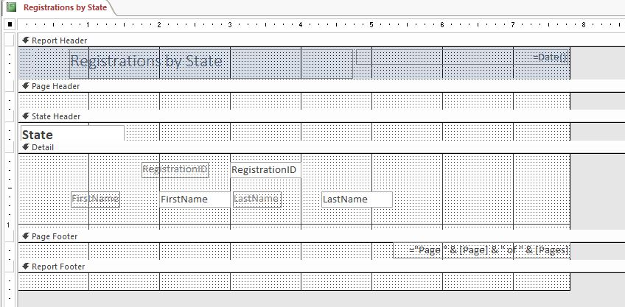~~

1. ~~Open the~~ *~~Workshop Charts~~* ~~form in Design View. In the~~ **~~Tab~~** ~~control, make the following updates:~~
   1. ~~Change the name of the first tab control using~~ **~~Attendees~~** ~~as the new name.~~
   2. ~~Change the name of the second tab control using~~ **~~Fees~~** ~~as the new name.  
        
      Save but do not close the~~ *~~Workshop Charts~~* ~~form.~~
2. ~~With the~~ *~~Workshop Charts~~* ~~form still open in Design View, switch to viewing the Pie chart in the first tab control. Modify the chart type so that it appears as a~~ **~~Bar~~** ~~chart. Compare the chart on the first tab control to the chart in Figure 8. Save but do not close the~~ *~~Workshop Charts~~* ~~form.~~

* ~~Figure 8: Workshop Charts Form – Attendees Tab in Design View~~

~~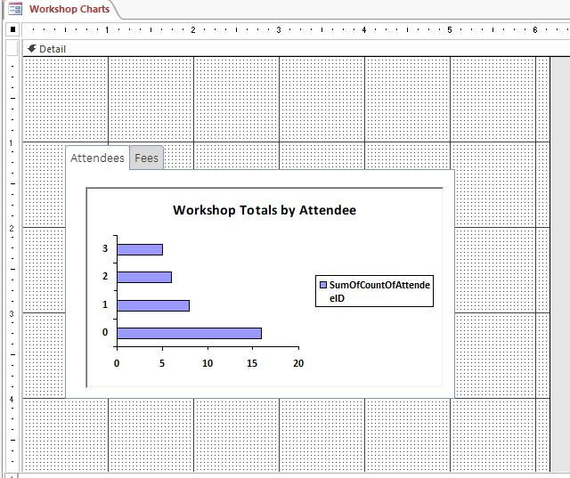~~

1. ~~With the~~ *~~Workshop Charts~~* ~~form still open in Design View, switch to viewing the second tab control. Insert a chart into the second tab control as described below:~~
   1. ~~Base the chart on the~~ *~~Workshop Totals~~* ~~query.~~
   2. ~~Use the WorkshopID and~~ *~~SumOfWorkshopFee~~* ~~fields (in that order) in your chart.~~
   3. ~~Use a~~ **~~3-D Pie Chart~~** ~~as the chart type for your chart.~~
   4. ~~The~~ *~~WorkshopID~~* ~~field should be the field for the series and the SumOfWorkshopFee (which will be renamed SumofSumOfWorkshopFee) field should be the field for the data in the chart. (~~*~~Hint:~~* ~~These fields should be assigned automatically to the correct areas in the Chart Wizard.)~~
   5. ~~Use~~ **~~Total Fees by Workshop~~** ~~as the name of your chart.~~
   6. ~~Display a legend in the chart.~~
   7. ~~If necessary, resize the chart object to the same size as the tab control as shown in Figure 9.  
        
      Save the form, compare it to Figure 9, and then close the form.~~

* ~~Figure 9: Workshop Charts Form – Fees Tab in Design View~~

~~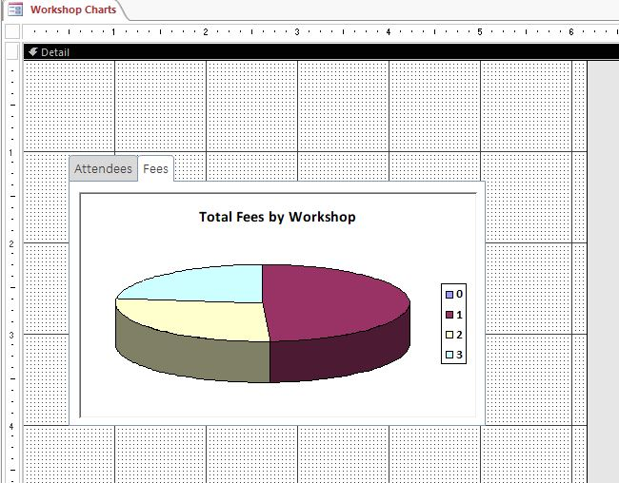~~

1. ~~Open the~~ *~~Attendee Registration Report~~* ~~in Design View. Remove the Page Header and Footer from the report. Save but do not close the report.~~
2. ~~With~~ *~~Attendee Registration Report~~* ~~still open in Design View, add a~~ **~~text box~~** ~~control to the~~ *~~AttendeeID~~* ~~header as described below:~~
   1. ~~Add the text box control to the~~ *~~AttendeeID~~* ~~header in the approximate location shown in Figure 10. (~~*~~Hint:~~* ~~The left edge of the control should align with the left edge of the~~ *~~AttendeeID~~* ~~control.)~~
   2. ~~Enter the following expression into the text box control:~~ **~~=[FirstName]&" "&[LastName]~~**
   3. ~~Reposition and resize the text box control so that the left edge is at the 1" mark and the right edge is at the 3" mark on the horizontal ruler as shown in Figure 10.~~
   4. ~~Set the Border Style property of the text box control to~~ **~~Transparent~~**~~.~~
   5. ~~Change the label associated with the text box using~~ **~~Name~~** ~~as the new label name.~~
   6. ~~Reposition and resize the label as necessary so that all text in the label is visible and the left edge of the label is at the .1" mark on the horizontal ruler.   
        
      Save the report but do not close it.~~
3. ~~With the~~ *~~Attendee Registration Report~~* ~~still open in Design View, ensure that the Use Control Wizards button is selected. Insert a subreport into the Details section of the report:~~
   1. ~~Add the subreport to the Details section at approximately the .5" mark on the horizontal ruler and the .5" mark on the vertical ruler.~~
   2. ~~Base your subreport on the~~ *~~Attendees and Registration~~* ~~query.~~
   3. ~~Include the~~ *~~AttendeeID~~*~~,~~ *~~RegistrationID~~*~~, and~~ *~~RegistrationFee~~*~~, (in that order) in the subreport.~~
   4. ~~Accept the default link (Show Attendees and Registration for each record in Attendees using AttendeeID).~~
   5. ~~Use the default name~~ **~~Attendees and Registration~~****~~subreport~~** ~~as the name of the subreport.~~
   6. ~~In Design View, delete the label associated with the subreport.~~
   7. ~~Reposition the subreport so that the upper left corner is at .5" mark on the horizontal ruler and the .5" mark on the vertical ruler. The bottom right edge of the subreport is at the 1.5" mark on the vertical ruler and the 5.2" mark on the horizontal ruler.~~
   8. ~~If necessary, resize the Detail section to the approximate size shown in Figure 10.~~

* ~~Figure 10: Attendee Registration Report in Design View~~

~~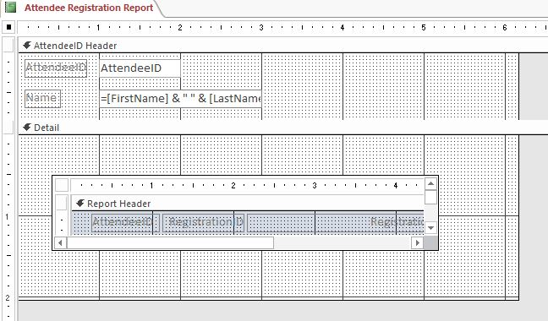~~

Save and close any open objects in your database. Compact and repair your database, close it, and then exit Access. Follow the directions on the SAM website to submit your completed project.